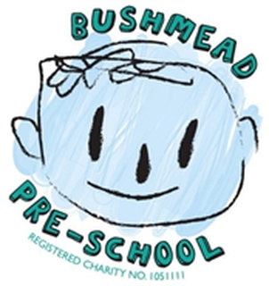
Bushmead Preschool Calpol Policy

For children attending all day 30 hour sessions only.
Not applicable for children attending AM and PM 15 hour sessions
At Bushmead Preschool, we try to minimise the spread of infection in our setting however, due to infections and childhood illnesses your child may be unable to attend. It is of the utmost importance that children who are ill or have infections are kept away from the nursery to help reduce the risk of spreading the infection or illness.
We may request that a child is sent home for several reasons, but please remember that we have a responsibility to keep all the children safe from illness and infection. Whilst it may be inconvenient, your child’s health and welfare and the welfare of others in our care, is our priority. We follow the guidelines for illnesses and infection control set out by Public Health England. https://www.gov.uk/government/publications/health-protection-in-schools-and-other-childcare-facilities In the event of a child infection or illness, staff at Bushmead Preschool will follow the following procedure to ensure the needs of your child are met and to prevent the illness or infection from spreading.
Bushmead Preschool will store a bottle of Calpol onsite to only be administered when a parent has been notified of a temperature, this is to avoid the temperature becoming any higher resulting in a possible convulsion. The parent must give verbal consent to this over the phone and then sign a medicine form on arrival.
If the child’s temperature is 38°C a member of staff will sit with the child and make him/her as comfortable as possible. In the meantime, another member of staff will contact the parent/carer explaining the situation.
We will request permission from the parent to administer Calpol.
The parent/carer will need to collect the child from Preschool to be cared for at home and seek medical advice if the following occurs:
- Calpol has not worked in reducing temperature from 38°C
- Calpol hasn’t offered pain relief
- The child’s temperature exceeds 38°C degrees

Policy created Dec 2024 by Management

